**HR Attrition Project Process**

**Problem:** Who is leaving the company and why?

**Dataset:** IBM HR Attrition Dataset from Kaggle

Once I downloaded the dataset from Kaggle, my first task was to clean the data and convert it to a table. It’s a fairly clean dataset so that was a quick process. With over 1,400 rows of employees and 34 columns of information, there was a lot to assess. I knew I needed to make named ranges out of the columns to make the analysis process more efficient. Once I created the names from the selection, my primary method for finding correlations was experimenting with Pivot Tables on another sheet. I started with the broad question of overall attrition and then proceeded to filter it down to department, job role, monthly income, commute (distance from work), age, job satisfaction, marital status, and more. I would also cross these factors over, analyzing the monthly income average per job role for example.

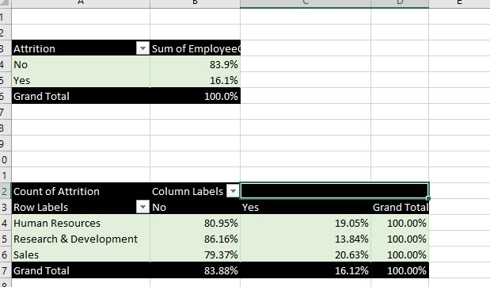

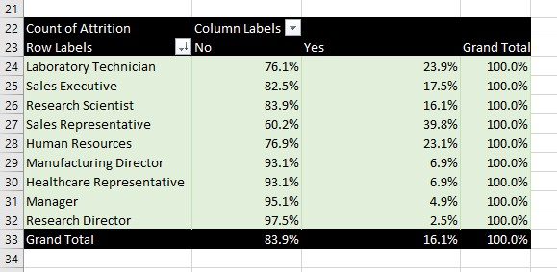

After playing around with a number of pivot tables, it became clear that the Sales department had the highest rate of attrition with Sales Representative being the job title that left the most at 40%. Lab technicians, Human Resources, and Research Scientists were a few other roles with a high rate of turnover. Focusing on these roles, I was then able to determine that they were some of the lower-income jobs in the dataset.

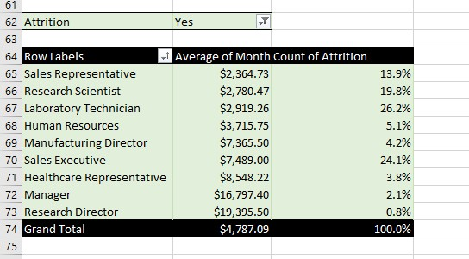

Marital status was another factor that was found to correlate with employees leaving. 26% of single employees in the dataset left the company, compared to just 12% and 10% for married and divorced employees respectively. Other details were looked into such as employee age, job satisfaction, and commute distance to work, but those did not reveal any significant numbers relating to attrition.

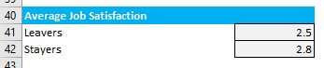

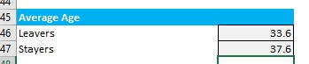

I centered my dashboard on these findings, creating KPI boxes with corresponding charts for visuals. These boxes were filled in with COUNTIF and AVERAGEIF functions for efficiency.

**Retention Program Recommendations**

Based on the findings, the best course of action would be to target the higher-attrition job roles and implement programs that could retain employees for longer durations. Here are some examples;

1. **Higher or more frequent performance-based incentives**

This applies most favorably to Sales Representatives, who have the highest attrition rate and the lowest average monthly salary. This could be a mutually beneficial approach that leads to improved overall performance and longer tenures at the company. Spot bonuses could achieve similar results.

1. **Work-Life Balance Initiatives**

Single employees are leaving the company at a higher rate. This could be a sign that it is difficult to maintain a satisfying work-life balance for employees who might have less structured home lives. If communal activities were introduced to the workplace, these workers would find more purpose in their work lives than simply a way to make ends meet. Trivia, social sports, book clubs, and any other organized social gatherings offered to employees could accomplish this.

1. **More Flexible Work Schedules**

Employees might feel like work dominates their time and find difficulty in managing their lives around it. Offering 4-day workweeks instead of 5 could encourage employees to maintain their position within the company. Hybrid or remote schedules for roles like Human Resources and Research Scientists could accomplish similar things.

1. **Manager Evaluations**

Leadership in the higher-attrition areas might need a closer look. If employees are not properly set up to succeed by their managers, they might feel more compelled to leave. Implementing training sessions for the managers could lead to healthier workplace relationships. Private consultations with workers in some of these higher-risk job roles could shed light on hidden issues that could not be seen in the data.

1. **Clearer Career Pathways**

Managers in all departments had some of the highest income and lowest attrition rate in the dataset. One cause for employees leaving could be a sense of a low ceiling at the company. Opportunities for growth and advancement could encourage employees to stay long term. Access to skill-building seminars could be enticing to any employees who feel stuck.

1. **Redesigning Job Satisfaction Tools**

The job satisfaction ratings did not prove insightful in the dataset. 2.5 to 2.8 is ultimately not useful in analysis. The process could some quantitative and qualitative redesign. Instead of a rating from 1-4, a rating from 1-10 could be a clearer first-glance look at an employee’s satisfaction with their job. Questions that lead to detailed responses could also be analyzed and reveal patterns.